***Covid-19 Helper***

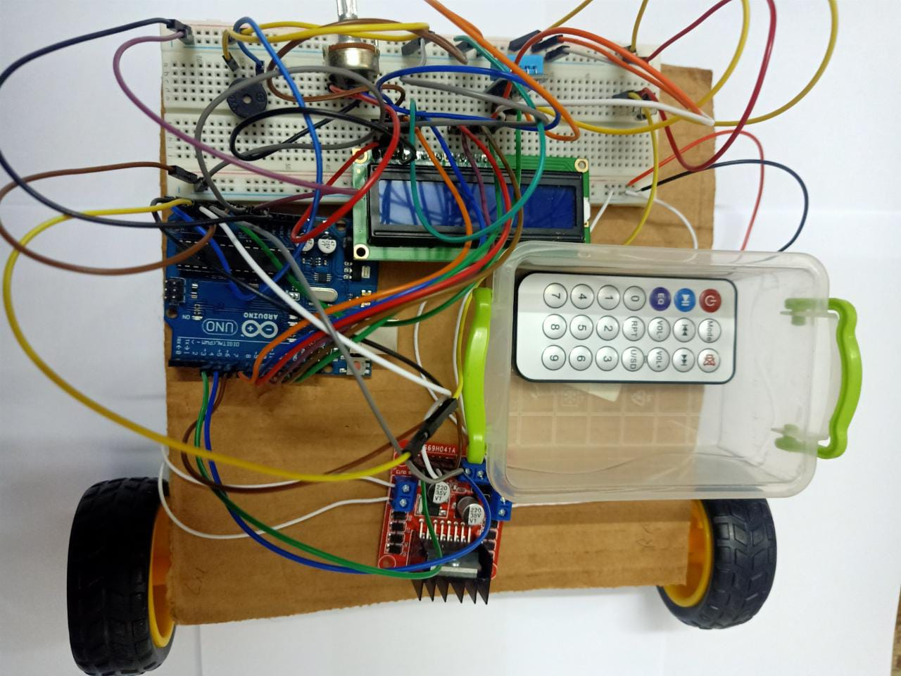

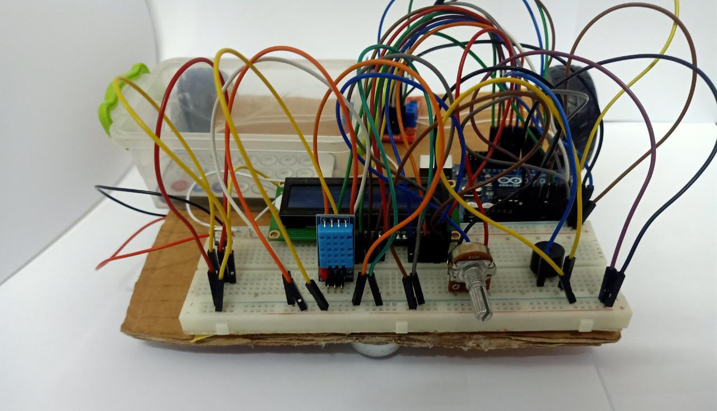

**COMPONENTS AND SUPPLIES :-**

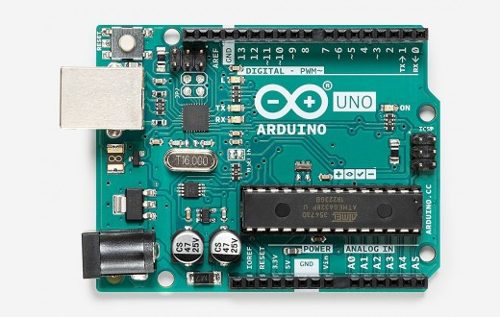

ARDUINO UNO

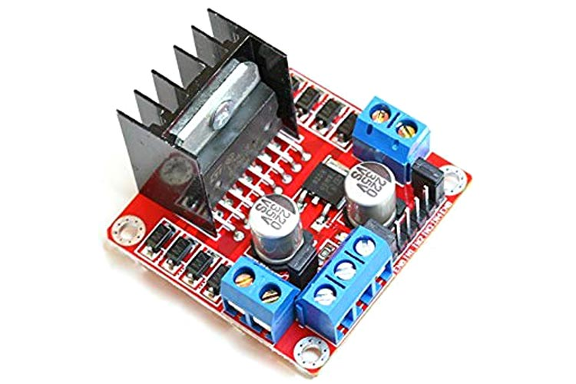

motor drivers l298

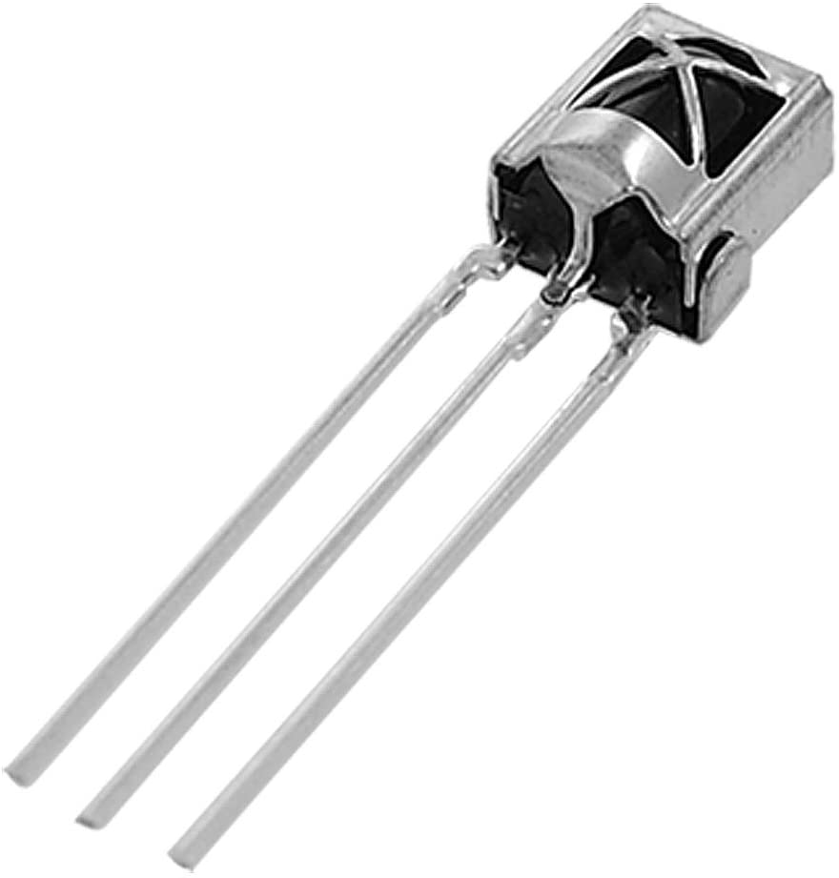

IR Recevier

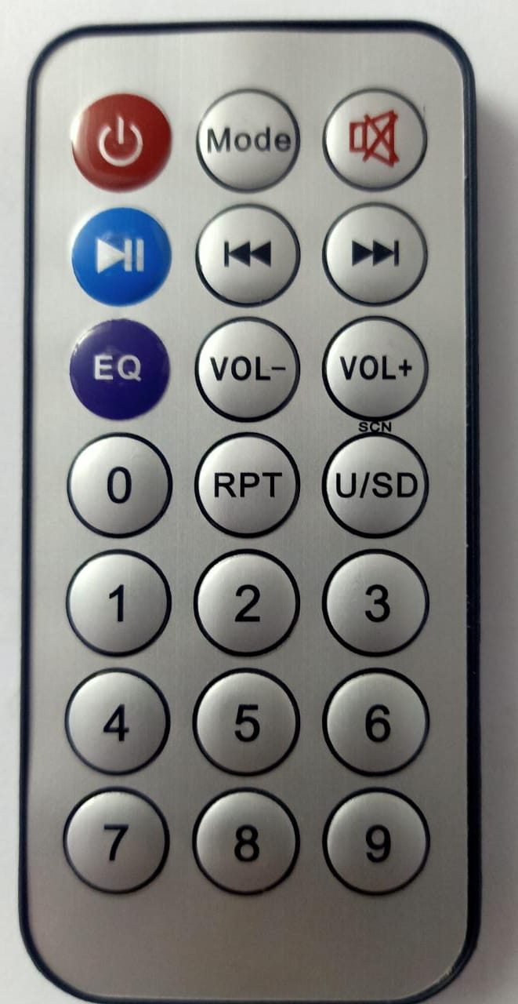

remote control

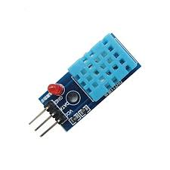

DHt11

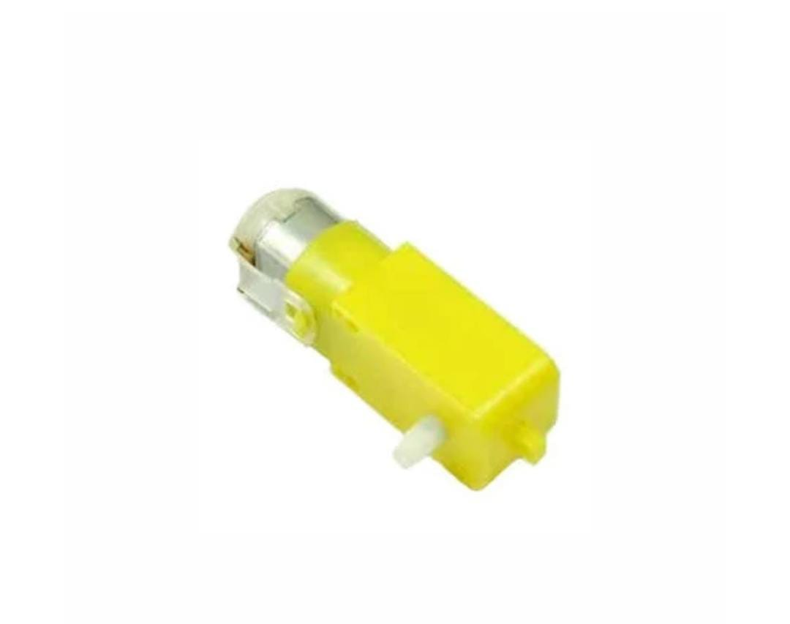

dc geared motors for robots(straight shaft)

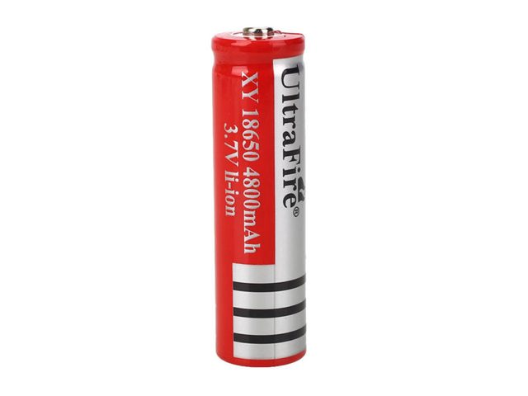

battery

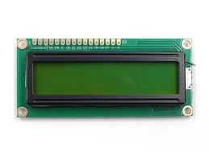

lCD

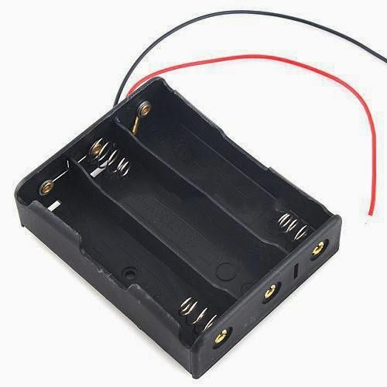

Battery holder

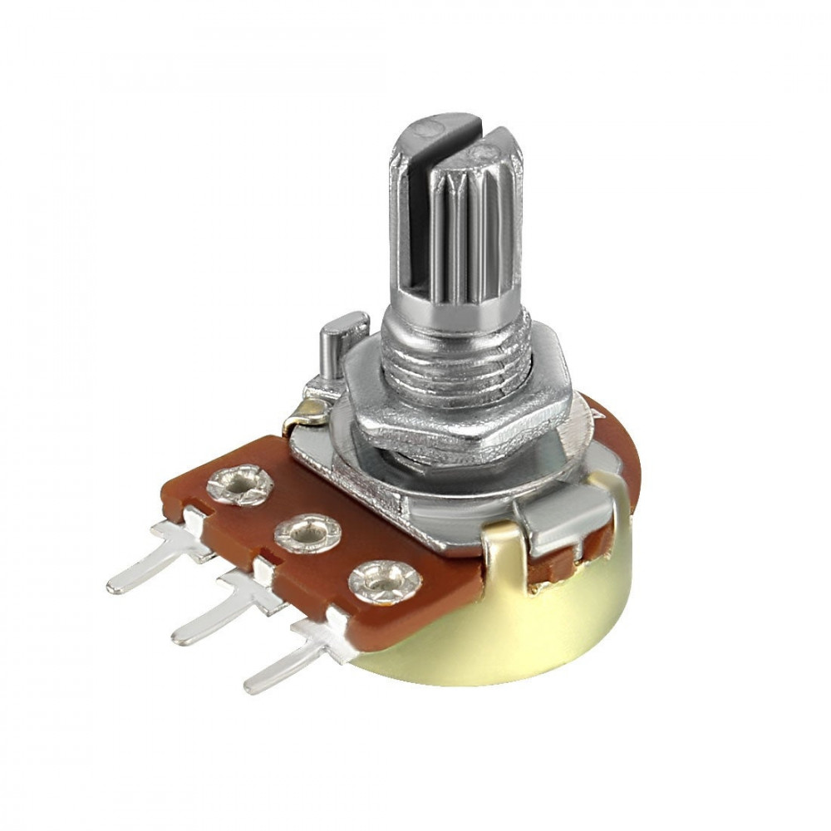

potentiometer

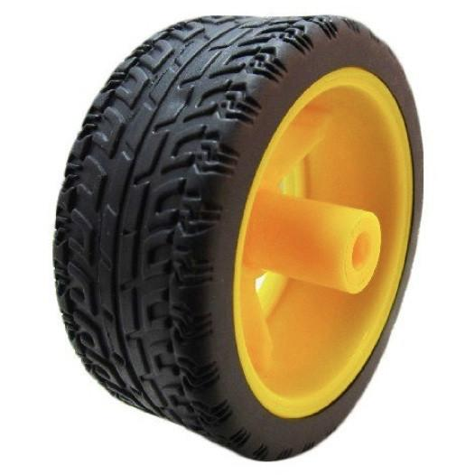

robot wheels

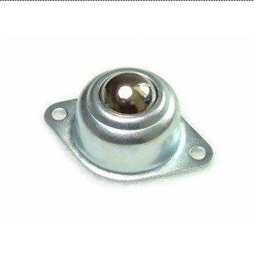

wheels caster

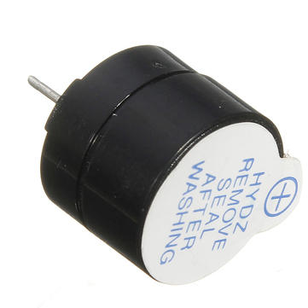

Buzzer

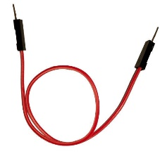

Male to male jumber wires

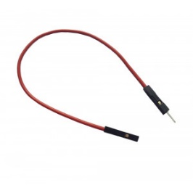

Male to FEmale jumber wires

**Project concepts :-**

1. What the project does :

Covid-19 Helper project is a technical project that serves the medical field to fight the Corona pandemic.Covid-19 Helper is a remote-controlled robot to perform the function of the nurse as it deals directly with Corona patients and measures and displays the required information such as temperature and humidity inside the intensive care, without the need for the human factor .

1. What are the importance of Covid-19 Helper :
2. The project greatly helps in fighting the pandemic and helping doctors, as it helps the supervising doctor in measuring medical information without the need for the doctor to do it himself
3. It reduces the chances of infection because it deals and communicates with patients directly, so that the doctor does not interact with the Corona patient
4. He can transfer medical tools and supplies to and from the intensive care room, thus increasing safety and reducing the chances of infection
5. The project is equipped with a tool to alert the doctor immediately if the measured results are not at the normal level or when something goes wrong so it provides continuous follow-up for patients.
6. It provides continuous follow-up and accurate results of measurements
7. Reducing the need for doctors or nurses because he works as a non-human nurse
8. It saves doctors' effort to what is more dangerous
9. It measures room temperature and humidity and shows the information continuously on the lcd
10. Explanation the project scientifically:
11. **Robot :**

The mechanism of working the remote-control robot:

A ***Remote*** act as an IR Transmitter and an***IC*** acts as a receiver, IR rays are one among the electromagnetic waves which is invisible to human naked eye, so we press the switches to make the robot move and control its moving.

The motor driver L298N It can control both speed and spinning direction of two DC motors. The L298N motor driver’s output channels for the motor A and B to connect two DC motors having voltages between 5 to 35V to these terminals, by Using the direction control pins, we can control whether the motor spins forward or backward .These pins actually control the switches of the H-Bridge circuit inside L298N IC , The **IN1** and **IN2** pins control the spinning direction of the right motor while **IN3** and **IN4** control left motor .

1. *Chart, waterfall chart

   Description automatically generatedif you press “Vol+” switch you make The helper move Forward, by making both wheels move in the Forward direction .*
2. *Chart, diagram

   Description automatically generated with medium confidenceif you press “Vol-” switch you make The helper move Backward, by making both wheels move in the backward direction.*
3. *Diagram

   Description automatically generated with medium confidenceif you press “*|*<<” switch you make The helper Turn Left, by making the Right wheel move in the Forward direction .*
4. *Diagram

   Description automatically generatedif you press “>>*|*” switch you make The helper Turn Right, by making the Left wheel move in the Forward direction .*
5. *if you press “on / off “ switch you make The helper Stop, by making both wheels stops.*

There are five conditions in this remote robot that we read by using Arduino , we write the code according to the conditions shown in table below .

|  |  |  |  |  |  |  |  |  |
| --- | --- | --- | --- | --- | --- | --- | --- | --- |
| **Left Motor** | | | **Right Motor** | | | |  | |
| LM1  *“left motor backward”* | LM2  *“left motor forward”* | | RM1  *“right motor forward”* | | RM2  *“right motor backward”* | |  | |
| *0* | | *0* | | *0* | | *0* | | Stop | |
| *0* | *1* | | *0* | | *0* | | Turn Right | |
| *0* | *0* | | *1* | | *0* | | Turn Left | |
| *0* | *1* | | *1* | | *0* | | Forward | |
| *1* | *0* | | *0* | | *1* | | Backward | |

1. **LCD :**

The LCD display 16 * 2 is the most useful, where the number 16 * 2 shows that this screen appears 32 seconds in two lines, and has 16 mail to deliver as described below.

**Features of 16×2 LCD module :**

* Operating Voltage is 4.7V to 5.3V
* Current consumption is 1mA without backlight
* Alphanumeric LCD display module, meaning can display alphabets and numbers
* Consists of two rows and each row can print 16 characters.
* Each character is build by a 5×8 pixel box
* Can work on both 8-bit and 4-bit mode
* It can also display any custom generated characters
* Available in Green and Blue Backlight

1. **Buzzer :**

Buzzer A device that converts electrical energy into audible sound .

It will make sound if an error occurs or if the measurements are not in the normal range

1. **DHT11 :**

DHT11 digital temperature and humidity sensor is a compound sensor with calibrated digital signal output. It use dedicated digital module acquisition technology and the temperature and humidity sensor technology

**Properties :**

* Operating Voltage: 3.5V to 5.5V
* Operating current: 0.3mA (measuring) 60uA (standby)
* Output: Serial data
* Temperature Range: 0°C to 50°C
* Humidity Range: 20% to 90%
* Resolution: Temperature and Humidity both are 16-bit
* Accuracy: ±1°C and ±1%

**DHT11 measures the humidity and the temperature and the results are displayed on the LCD, and if the humidity is less than 40 (<40) OR the temperature is less than 25 (<25) , the BUZZER will make a warning sound .**

**the Circuit of the project :-**

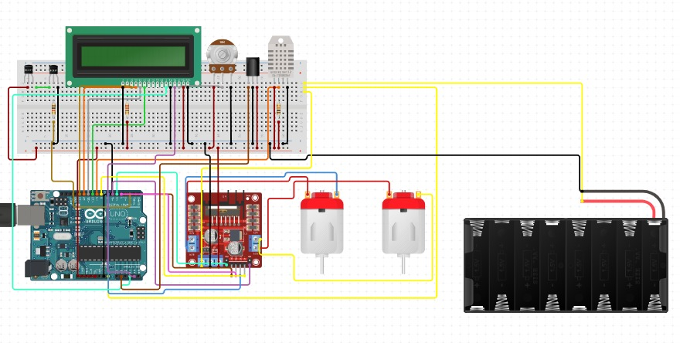

**code of the project :-**

